Jordan Cartwright

Object Oriented Programming

Homework 2 Questions

1. *Is there a better removal system for the offensive troops? Instead of the current system of choosing the cheapest units, should the attacker try something else? That something else could mean, for example, losing air power before ground troops.*

The best removal system that I was able to conclude was the removal of troops in the following order: {Infantry, Artillery, Fighters, Bombers, Tanks}. I conducted tests with six different removal methods that averaged together at 49% with the outlier with a 52.3% average win rate. I concluded that this was going to be one of the best if not the best removal method because the average win percentages were beginning to stagnate around the 50% mark give or take a few percent.

What led me to the conclusion that my average win percentage was not going to increase any further by a significant amount was by looking at a breakdown of each individual test. I compared all the specific tests for my tests together on a line graph.

On this graph I was able to conclude that the difference between each method was very small and not that different once it began to increase slightly. Therefore I concluded that the removal order solution that is most optimal on a measurable scale to be {Infantry, Artillery, Fighters, Bombers, Tanks}.

1. *How is the defense affected now with the addition of anti-aircraft units? Assuming that AA units fire according to the rules, and are now removed by the defense before infantry, how would these affect combat with standard forces?*

After running a simulation with the addition of the Anti-Aircraft unit, I concluded that the win rate for the defense increases with any value greater than zero for the number of Anti-Aircraft units. This means that the defense is positively impacted by the addition of the AA units. I arrived at this conclusion under the assumption that the attackers are using the original, “cheapest unit first” removal method and *not* the optimized method found in question 1. After noticing that with an AA value of 5, the removal method had a positive impact on the defenders win percentage. I then decreased the values (from 5 – 0) to find that with each test, decreasing the number of Anti-Aircraft units had a negative effect on the win percentage for the defense.

This lead me to believe that the decrease Anti-Aircraft units correlated with an increase in attacker win percentage therefore leading me to the conclusion that the defense is positively impacted by the inclusion of the AA units. I then wondered if changing the order in which the defensive units were removed would have any effect on their ability to improve the chance of victory. My conclusion, as long as the defense does not use the “cheapest unit first” removal method it appears that there is an increase in defender win percentage however the order does not matter, as it plays no significantly measured role.

Once I changed the “cheapest unit first” removal method, the attacker’s win percentage fell and stagnated at about 13% with an insignificant amount of fluctuation between each of the removal methods.

1. *Given 100 units of cost, what is the most effective attacking force against 33 Infantry (essentially 100 units of defense)?*

What I believe to be the most effective attacking force against 33 defending infantry is 16 infantry and 13 Artillery. This is based upon a series of tests I conducted with varying Attack Army buildups. With this attacking force I was able to achieve a win percentage of 10.6%.

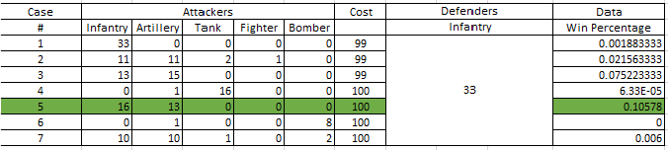

1. *Given 100 units of cost, what is the most effective defensive force against 10 tanks and 4 fighters?*

What I believe to be the most effective defensive force against 10 tanks and 4 fighters is an attacking army composed of 33 infantry units. This yields an attacker win percentage of 0% indicating that the defenders are always able to fend of the incoming attack.

